# **Understanding the Racial Bias of Stop and Search in Greater London**

Ying Chen

CASA0010 for MSc Dissertation Supervised by Dr. Andrew MacLachlan Word Count: 10,365

This dissertation is submitted in partial fulfillment of the requirements for the degree of MSc in the Centre for Advanced Spatial Analysis, Bartlett Faculty of the Built Environment, UCL.

21 August 2021

**Abstract**

The use of stop and search in the UK is controversial for its inefficiency and racial discrimination towards minority groups. Previous studies argue it serves as an investigative tool and has little effect to deter crimes. However, in April 2019 the Home Office authorised more officers to use stop and search to tackle knife crimes. Two years later, this paper examines the justness and effectiveness of stop and search conducted by the Metropolitan Police in Greater London from April 2019 to April 2021. Through point pattern analysis via DBSCAN and disproportionality analysis, this study provides evidence of potential racial discrimination in police use of stop and search powers to specific boroughs and MSOA; and further explores factors that could explain local variation of stop and search arrest rate by Geographically Weighted Regression and local Moran’s I maps. The results show a higher search rate or crime rate will lead to a higher arrest rate, but the overall effect is very minor (lead to < 0.1 percent increase). The number of successful stop and search might not be determined by the quantity of searches but the quality. To assess and quantify the quality of stop and search, suggested socioeconomic factors such as deprivation fails to predict arrest rate whereas bad health percent and car ownership are more related to arrests. Knowing the issues of current use of stop and search, this paper suggests the following ways to improve the effectiveness and fairness of stop and search: (1) information sharing between forces; (2) reducing drug search at non-targeted areas; (3) using hit rate to evaluate policing effectiveness and racial bias; (4) add a field of ‘found weapon’ to the current stop and search dataset to gather solutions to tackle violent crimes from the public. (5) targeting searches at crime or population hotspots is not a quick solution to improve stop and search performance; a long-term strategy is in need.

**Declaration of Authorship**

I, Ying Chen, hereby declare that this dissertation is all my own original work and that all sources have been acknowledged. It is 10,365 words in length.



Ying Chen

21 Aug 2021

**Acknowledgements**

I would like to thank my supervisor, Dr. Andrew MacLachlan, for his advice and assistance to every aspect that the dissertation has been through. I would also like to thank my boyfriend and my parents for their support and encouragement during the pandemic so that I could concentrate on my work.

# **Contents**

Contents 5

List of Figures 6

List of Tables 7

Introduction 8

Literature Review 11

2.1 History of stop and search and related legislation 11

2.2 Issues of Stop and Search 14

2.3 Misinterpretation about the Stop and Search Data 16

2.4 Methods for Understanding Stop and Search 17

Data 21

3.1 Data Sources 21

3.2 Point-to-Polygon Aggregation 24

Methodology 26

4.1 Point Pattern Analysis 27

4.2 Disproportionality Analysis 29

4.3 Spatial Autocorrelation 30

4.4 OLS and GWR 30

Results 33

5.1 Descriptive Statistics and Maps 34

5.2 Racial Disparities 37

5.3 Stop and Search Hotspots 41

5.4 Regression Models 43

Discussion 47

Conclusion 52

Bibliography 53

# **List of Figures**

**Figure 1:** Number of recorded crimes by crime types in Greater London. 23

**Figure 2:** Overall trend in the number of stop and searches by ethnic groups 24

**Figure 3:** Methodology flowchart. 28

**Figure 4:** Ripley's K-Function to determine distance parameter in DBSCAN. 30

**Figure 5:** Thematic maps of relative search rate in Greater London. 39

**Figure 6:** DBSCAN results. 40

**Figure 7:** Hit rate comparison between the whites and the minority. 42

**Figure 8:** Thematic maps of hit rate by race. 44

**Figure 9:** Local Indicators of Spatial Association (LISA) maps. 46

**Figure 10:** Maps of GWR results. 49

# **List of Tables**

**Table 1**: Description of the legislation associated with UK stop and search 15

**Table 2**: stop and search legislation statistics. 36

**Table 3**: Main variable’s borough-aggregated statistics. 37

**Table 4:** Crime and stop and search borough-level statistics. 38

**Table 5:** Stop and search statistics by race. 42

**Table 6:** MSOA-aggregated hit rate statistics by race. 43

**Table 7:** Global Moran's I statistics for variables used in regression analysis. 46

**Table 8:** Regression results of global arrest rate in relation to search rate and inner outer London. 48

**Table 9**: Regression results of white arrest rate in relation to white search rate and inner outer London. 48

**Table 10:** Regression results of black arrest rate in relation to black search rate and inner outer London. 49

**Table 11:** Regression results of Asian arrest rate in relation to Asian search rate and inner outer London. 49

**Table 12:** Regression results of global arrest rate in relation to multiple socioeconomic factors. 50

**Table 13:** ST-DBSCAN cluster results. 58

**Chapter 1**

# **Introduction**

In the United Kingdom, the term “stop and search” can be used in a variety of contents describing the contacts between police officers and the public (Miller et al., 2020). The dominant form of stop and search is used when officers stop members of the public either on a vehicle or on the street and search for certain illegal items. This form of stop and searches is what the analysis aims to study at. The purpose of the stop and search carried out in London is controversial and most of the academic research proves it mainly serves as an investigative tool and has little effect of deterring crimes in general (Brookman and Maguire, 2005; Bowling and Phillips, 2007; Miller et al., 2020). Although the recent work by Tiratelli, Quinton and Bradford (2018) have shown some association between the number of stop and search and drug crime using data from 2004 to 2014 in London, they conclude the overall effect of stop and search is not “crime-fighting” but more towards a wider social control. Not only the stop and search are proven to have little positive feedback in catching crimes, its negative impact has aggravated the tension between some minority communities and the police because of the disproportionate searches between blacks, Asians and whites (Brown, 2019; Miller et al., 2020; Constabulary and Fire, 2021). Racial disproportionality also found in Canada and the US (Wortley and Owusu-Bempah, 2011; Pierson *et al.*, 2020). The issue that black and Asian people are more likely to be stopped and searched than the white people in the UK first starts from survey in the 19 centuries when the publicly police data has not been available yet. It was not until the murder of a black teenager Stephen Lawrence in 1999 that raised the question of police misuse of stop and search power particularly the section 60 of the Criminal Justice and Public Order (section 60) towards minority groups and as a result, more reformation on building better strategies of the use of the police power is taken in the 20centuries to help police rebuild trust and enhance police public image.

The reasons for the racial disparities in stop and search have arisen heated debate in the field of criminology for its potential violation in human rights, misuse of police power and even racial discrimination in certain police forces (Constabulary and Fire, 2013). However, racial disparities do not necessarily lead to racial discrimination and the key is to understand and interpret the disproportionality accurately and then decide if it is a natural product or a police-led outcome (Commission on Race and Ethnic Disparities, 2021). Methods of evaluating the effectiveness of stop and search include qualitative analysis, such as surveys and interviews (Constabulary and Fire, 2013; Miller et al., 2020), case studies (Commission (EHRC), 2010), and quasi-experiments (Bradford and Tiratelli, 2019), and quantitative analysis such as lagged regression models (Tiratelli, Quinton and Bradford, 2018) and time series analysis (Bradford and Tiratelli, 2019). Although the term “intelligence-led policing” has been widely used in government’s report, it has been proven that very few forces use crime hot spots or similar geographically led approach to allocate stop and search (Constabulary and Fire, 2013; Commission on Race and Ethnic Disparities, 2021). Moreover, the current spatial analysis on stop and search in London tends to focus on crime hot-spot investigation at borough level data with a lack of focus on finding patterns on smaller geographic units and the conclusion often does not account for a variable’s local variation or the presence of time.

Therefore, the research question addressed in this study is: what is the spatial pattern of the people with different ethnic groups who have experienced stop and search during the past two years in Greater London neighborhoods and can the stop and search patterns be explained by any socio-economic variables? Using the police open data, the study hopes to answer the question by a combined use of point pattern analysis, spatial autocorrelation and geographically weighted regression. More specifically, the paper aims to address the following objectives:

1. What is the distribution of the stop and search targeted at the blacks, whites, and Asians respectively in Greater London during the past three years – are they all randomly distributed or clustered?
2. What are the proportion of stop and searches that lead to arrests for different ethnic groups in Greater London neighborhoods – is there any evidence of racial discrimination?
3. Is increasing stop and search potentially lead to more or less arrests across Greater London neighborhoods – are stop and search arrests distributed randomly or associated with the number of searches? Will the outcome be different for different minority groups?
4. What are the factors that might lead to variation in arrest rate across the city? Can the model explain local variation?
5. Most importantly, knowing the Home Office has authorized more officers with stop and search power to tackle knife crime, can the findings of the research be used to justify the Home Office’s strategy to handle violence? If not, can the findings provide insights on geographically led strategy in stop and search.

**Chapter 2**

# **Literature Review**

Building from the basic concepts about stop and search introduced in the last chapter, this chapter elaborates into four sections including the history of stop and search and related legislation (2.1), current issues of stop and search from both the police forces perspectives (2.2.1) and police-makers perspectives (2.2.2), misinterpretation about the stop and search ethnic data (2.3), and methods for understanding stop and search (2.4).

## **2.1 History of stop and search and related legislation**

The term “stop and search” is used globally as a coercive practice that often empowers polices to search and control the public based on legal legislation related to crime offences (Bowling and Weber, 2011). The use of stop and search for the purpose of crime prevention dated back to the 1824 Vagrancy Act which gives officers the power to search suspicious people including reputed criminals who might commit crime again on highway (Delsol and Shiner, 2006). Later on, based on the Section 66 of the 1839 Metropolitan Police Act, polices in London are authorised power to arrest people with reasonable suspicion or carrying stolen objects. However, because the Police Acts in the 1980s does not require “external evidence” such as recorded words from witness or police report, an officer could arrest a person with bias, and this led to disproportionate stop and search powers imposed on minority groups (*ibid*).

In fact, the concern on the over-policing towards black communities originated in the 1960s and the widely use of stop and search exacerbated the tension between black communities and the police. The Institute of Race Relations (1979) reported numerous cases where many black parents constantly worried about their children going out and not returning home as expected because of detaining in the police station (*ibid*). However, studies have shown young black males constantly being stopped and searched without reasonable suspicion (Smith and Gray, 1983). The 1981 Brixton riots due to long-term resentment by black communities against the police marked as the beginning of policing reform led by Scarman. However, despite of some improvements made after the publication of the Scarman Report, two decades later, the murder of a black teenager, Stephen Lawrence pushed the debate on policing racism again. The death of the black teenager was concluded in Delsol and Shiner’s 2006 study as “a combination of professional incompetence, institutional racism and a failure of leadership by senior officers” (cited in Macpherson 1999, para 46.1). Ever since, the studies of racial discrimination in police use of stop and search become popular in academy. In 2017, the UK government granted open access to the stop and search data including the suspect’s personal information, the geographic location and the legislation of the stop and search (Constabulary and Fire, 2021).

The publication by the Equality and Human Rights Commission in 2010 provides a thorough review of the legislation of stop and search in the UK in the following table.

**Table 1**: Description of the legislation associated with UK stop and search

|  |  |  |  |
| --- | --- | --- | --- |
| **Legislation Name** | **Main powers\*** | **Requirement of Reasonable Suspicion** | **Requirement of Senior Officer Authorization** |
| Section 1 of the Police and Criminal Evidence Act 1984 (PACE) | Search a person or vehicle for stolen or illegal items | Yes | No |
| Section 23 of the Misuse of Drugs Act 1971 | Search a person or vehicle for controlled drugs | Yes | No |
| Section 47 of the Firearms Arc 1968 | Search for firearms | Yes | No |
| Section 163 of the Road traffic Act 1988 | Stop driving vehicle or cycle when the suspect (who has committed crime or about to) is on the vehicle | Yes | No |
| Section 43 of the Terrorism Act 2000 | Stop a person who might be a terrorist with reasonable suspicion | Yes | No |
| Section 44 of the Terrorism Act 2000 | Stop a person who might be a terrorist without reasonable suspicion but only within specific areas | No | Yes |
| Section 60 of the Criminal Justice and Public Order Act 1994 | Stop and search people for up to 48 hours based on officer’s personal belief that serious violence may or have taken place. | No | Yes |

*contents also modified based on a report by HMIC (Constabulary and Fire, 2013)

The definition of the term ‘reasonable suspicion’ in Table 1 is obtained from the EHRC Commission report (cited from the Code of Practice in PACE) which states,

“there must be an objective basis… based on facts, information and/or intelligence which are relevant to the likelihood of finding an article of a certain kind… [and] should never be supported on the basis of personal factors… [such as] a person’s age, race, appearance or the fact that the person is known to have a previous conviction. Reasonable suspicion cannot be based on generalisations or stereotypical images of certain groups or categories of people as more likely to be involved in criminal activity (Commission (EHRC), 2010, p.16).”

Racial discrimination appears when the police makes a decision based on the stereotyping characteristics of a group of people rather than an individual’s behaviors. The racial backgrounds become the main reason for classifying people into groups rather than the suspicious activities. For example, if black people have been systematically stopped and searched more often than others regardless of their behaviors, the police has racial discrimination on the blacks (Wortley and Owusu-Bempah, 2011). Therefore, the dominant use of stop and search without reasonable suspicion has been critised for targeting blacks and Asians with racial discrimination and stereotyping policing (Bowling and Phillips, 2007) and this leads to the next section of current issues of stop and search in London.

## **2.2 Issues of Stop and Search**

Knowing some police forces might misuse the stop and search powers to arrest people without a reasonable suspicion and many searches were unproductive, this section reviews the issues of stop and search from two perspectives, police officers who conduct the stop and search and police-makers who initiate the rules and monitor the stop and search.

***from the police forces perspectives***

Previous research has shown the police tend to stereotype and label people based on their race, appearance and clothing when conducting stop and search, leading to racial disparities disproportionality (Wortley and Owusu-Bempah, 2011). Based on statistics covering data for entire UK by 2010, the EHRC Commission concludes black people are at least six times more likely to be stopped and searched than white people; Asian people are around twice as likely as white people. The disproportionality aggravates in section 60 (without requiring reasonable grounds) alone where black people in London are 18 times more likely than whites to be stopped and searched (Constabulary and Fire, 2021). Miller et al. (2020) found evidences that some police officers depended on racial prejudice rather than actual reasonable grounds when making stop and search decisions. Evidence from surveys, questionnaires, and interviews revealed officers had applied “experience-based rules of thumb” to group people into social categories by appearances. They concluded although the results from qualitative studies might not be rigorous and comprehensive, at least it has shown some examples witnessed by study researchers that race played an important role in police decision-making processes.

Not only the issues of racial bias, previous studies found that police forces also have other unlawful behaviours in the following: 1) reasonable suspicion is often missing in many instances that require it (Bowling and Phillips, 2007); 2) very few forces have developed intelligence-led stop and search strategy such as using crime hot spots to allocate police (Commission on Race and Ethnic Disparities, 2021); 3) there is a lack of standard stop and search data recording template or a national recording system to ensure data is collected unbiasedly and completely (Constabulary and Fire, 2013). They have found some officers tend to not record whites because they have known each other, and each force collect the relevant information differently resulting in incomplete ethnicity data.

**from the policy-makers perspectives**

On the other hand, some of the police’s unlawful behaviours could be explained by a lack of regulation and national standards. By interviewing 198 police officers about the sue of stop and search in 10 research sites across the UK from 1999 and 2003, Quinton (2011) argued the definition of reasonable suspicion was vague and officers usually had their own understanding of the standards. Sometimes standards generated by officers were contradictory from one to another. Quinton pointed out driving fast or slow, making eye contact or not could all be suspicious. The difference between standards was not only between individual officers, but also in regions. Despite of having similar crime priorities, the number of stop and search and the purpose of stop and search in Hackney was very differed from what in Chapeltown.

Moreover, there is a gap between the purpose of stop and search and the actual outcome. Initially, stop and search was mainly for finding stolen goods; however, in recent years, due to the prevalence of violence occurred in the city, the main purpose of stop and search shifts to (cited in Home Office in 2017) “take as many offensive weapons, knives, guns… out of the pockets of criminals as possible” (Commission on Race and Ethnic Disparities, 2021). In 2019, the Home Office has announced a plan to authorize more officers with stop and search powers to tackle knife crime (Home Office, 2019). However, many papers including the government report found the majority of searches is based on suspicion of drugs not violent weapon, and most of the drug searches lead to no further actions (Eades and Centre for Crime and Justice Studies (Great Britain), 2007; Matt Ashby, 2020; Commission on Race and Ethnic Disparities, 2021). In addition, many research found increasing in stop and search would not lead to a distinct drop in recorded violent crimes and the overall stop and search effect on crime was “marginal” (Bowling and Phillips, 2007; Tiratelli, Quinton and Bradford, 2018; Bradford and Tiratelli, 2019). They concluded the goal of stop and search was not crime detection but a wider “social control” at marginal communities. A recent report from Commission on Race and Ethnic Disparities (2021) attributed this disconnection to a lack of transparency and clarity between the government and the police; however, no response or plans were carried out yet.

Furthermore, there is a lack of uniform program or strategy to train police officers so that they not only know how to conduct stop and search but also understand the history, purpose, impacts and potential reasons for racial disproportionality. The research by Constabulary and Fire (2013) found many officers were lack of proper training before or after joining the service and as a result, many inexperienced officers developed habits through watching and listening to others, leading to potential unlawful practices. Moreover, stop and search under section 60 were almost entirely used without any training, and only 19 out of the total 43 police forces regularly monitored the use of section 60. Furthermore, Miller et al., (2020) examined the effect of 1-day pilot training program to reduce racial bias in police use of stop and search and they concluded although the training could correct their racial prejudice to some extent, the 1-day training alone was less likely to have a huge impact on the officers’ behaviors on the street.

## **2.3 Misinterpretation about the Stop and Search Data**

The last section described some issues resulting from disproportionate stop and search of minority groups. However, the reasons for ethnic disproportionality are complex and often need addition thinking on what the data represents. For example, a higher proportion of black searches might because more black people living in that area, so it is reasonable to conduce more black searches there. Without a careful reflection, it is easy to manipulate or interpret ethnic data with bias unintentionally.

***Street Population***

When calculating the ethnic stop and search rate and crime incidence rate, most research used the number of incidents divided by the resident population from the census (Commission (EHRC), 2010); however, it is considered as a rough and sometimes an inferior estimation because the number of people on the street who might be stopped and searched is mobile (EVANS, 2001). Instead, “street availability” (*ibid*) or “available population” (Miller et al., 2020) is considered to be a more accurate estimation because it separates total resident population into daytime and nighttime available population, accounting for the change of traffic flow in a day. However, it is difficult to evaluate street population on a daily basis and data about the ethnic visitors in a city is not regularly collected, limiting the accuracy of many stop and search analysis results (Delsol and Shiner, 2006; Constabulary and Fire, 2021).

***Hit rate***

Rather than using proportion of ethnic search, hit rate which calculated as the number of successful stop and search (i.e. arrests) divided by the total searches is another measure of disproportionality (Bowling and Phillips, 2007; Pierson et al., 2020). If the minority hit rate is considerably lower than the white’s, it means the police tend to extensively search the minority groups but get limited arrests. In order words, it proves the police unfairly targeted their objects based on race rather than suspicion and this “double standard” also exemplifies racial discrimination (Pierson et al., 2020).

## **2.4 Methods for Understanding Stop and Search**

The final section of the literature review will discuss the existing and potential research methodologies towards a geographically led stop and search. As introducing at the beginning of the paper, the majority of the crime spatial analysis stops at finding hotspots but there are much more could do with the spatial data. The following methodologies are applicable to the paper’s research objectives and provides fundamental concepts for this paper’s methodology.

***Spatial analysis***

Hotspot analysis is a traditional method in crime mapping. Constabulary and Fire (2021) mapped the crime hotspots and compared the locations with stop and search arrest rate. They found places where stop and search with reasonable grounds targeted at crime hotspots resulted in a lower arrest rate. However, they also argued the use of crime hotspots as the reasonable grounds was unlawful and the crime hotspots should not be the purpose of searches.

Crime hotspots or Kernel Density Estimation (KDE) maps can only discover global pattern and cannot highlight local areas with different spatial concentration (Chainey and Macdonald, 2012). Instead, the local indicators of spatial association (LISA) statistics and Getis-Ord Gi* (Gi*) maps were introducted and they are products of spatial autocorrelation (Eck et al., 2005). Spatial autocorrelation is a correlation measure of data values strictly to their relative locations (Medina, 2021). As explained by Ratcliffe (2010, p.7), “[it] relates to the degree of dependency between the spatial location and the variables measured at that location”. For example, the stop and search rate in an area might be influenced by its neighbor because the Tobler’s first law of geography tells us near things are more related than distance things (Rogers, Castree and Kitchin, 2013). Chainey and Macdonald (2012) applied Gi* maps to crime and stop and search hotspots and concluded no obious evidence showing the corresponding location between stop and search and crime over time. Furthermore, Mencken and Barnett (1999) used local Moran’s I and G statistics to detect spatial autocorrelation pattern between murder and manslaughter for counties in the US.

Spatial autocorrelation is also commonly used in Ordinary Least Square (OLS) regression to test whether residuals are spatially random and further incorporate with geographically weighted regression (GWR) (Ratcliffe, 2010). For example, the results of Bradford and Tiratelli’s research (2019) showed increasing 10% of stop and search in London would drop crimes by 0.3% by month; however, the number was a global coefficient and did not account for spatial variation at local level. There might be some patterns in the residuals suggesting some areas are affected greater than the others; thus, a standard OLS fails to capture local variation. As a result, GWR was introduced. In addition to provide a global estimation of variable that OLS does, GWR also accounts for the “geographic interaction effect” (Ratcliffe, 2010), so that the result of GWR includes not only a global coefficient but local coefficients varied for each spatial unit. Relative work includes the analysis of county-level crash incidents in California with a Geographically Weighted Poisson Regression model (Li et al., 2013) and health studies of examining the geographical distribution of routine tuberculosis cases with respect to distances to hospitals and other factors (Bui et al., 2018). There is a lack of research in applying GWR to understand variations in stop and search rate across neighborhoods and this paper aims to contribute to bridge the gap.

***Spatial-temporal analysis***

Crime mapping is not limited at location-based analysis but could also incorporate time. Chapter two of Ratcliffe's book Handbook of Quantitative Criminology (2010) describes the spatial and temporal challenges in crime mapping. He argued the existing spatial criminology focused on optimizing crime hotspot detection methods while the spatial-temporal crime distribution was lack of attention. For easily repeated crime types such as burglary, he argued temporal constraint such as a monthly, hourly or seasonal trend is vital to provide crime prevention solutions.

In response, building upon the two-dimensional density based clustering algorithm named DBSCAN (Hahsler, Piekenbrock and Doran, 2019), Birant and Kut (2007) developed ST-DBSCAN for detecting spatial-temporal patterns. Brusilovskiy et al., (2020) applied ST-DBSCAN algorithm in their community mobility study to identify clustered destinations from GPS data. Moreover, Gordon McDonald (2020) modified the ST-DBSCAN algorithm and made a package in R for an easy use.

Wooditch and Weisburd (2016) employed a bivariate spatiotemporal Ripley’s K function on crime and Stop-Question-Frisk data in the US (similar to stop and search in the UK) to monitor the deterrence effect of SQFs on crime distribution at a daily basis. They found different crime types behaved differently in spatiotemporal clustering. For example, burglaries often clustered at a same area for at least one month before shifting patterns. This gives police time to allocate officers to stop and search during the one-month period.

**Chapter 3**

# **Data**

Chapter 2 described the history, issues, and current research of stop and search, including the misinterpretation on stop and search data. This chapter will go through the data manipulation process before the analysis. Because there were over one million crime incidents and one hundred thousand stop and search observations in Greater London from April 2019 to April 202, it took a considerable work and time to clean data; eventually, all observations were aggregated to MSOA or boroughs to calculate the relative rate. The modifiable areal unit problem (MAUP) was present in this analysis, meaning the results was dependent on the map boundary (Ratcliffe, 2010). Therefore, the paper will make it clear about the selected map boundaries during the analysis. This chapter is divided into cleaning crime data (3.1.1), stop and search data (3.1.2), point-to-polygon aggregation to calculate relative rates (3.2.1), and joining with additional dataset (3.2.2). The code used in the project were written in R and can be found at https://github.com/yingchen20/dissertation2021.

## **3.1 Data Sources**

All of the data was obtained and downloaded online with free access. Both crime and stop and search data were obtained from <https://data.police.uk/data/>, and the website supported customized download by choosing a data range and police force; the London spatial boundaries was obtained from London Datastore at <https://data.london.gov.uk/dataset/statistical-gis-boundary-files-london>; and the London demographic data was obtained from <https://data.london.gov.uk/dataset/msoa-atlas>. Although stop and search data involves some personal information including age and self-identified ethnic group, all police data are under the Open Government Licence which allows the public to “copy, publish, distribute and adapt the information” freely, so the ethical issue is minor (The National Archives, no date).

The data range was from April 2019 to April 2021 because the release month of the Home Office’s plan of increasing stop and search power was in April 2019. Thus, this paper aims to find the cumulative effect from the initiation of the plan up to the recent time. The Metropolitan Police Service force is the only selected police force. The reason for not combing the City of London Police with the Metropolitan Police force is because research has shown each force collected the information differently (Constabulary and Fire, 2013). For the purpose of consistency on the use of stop and search, this paper only considers stop and search in the Greater London.

The crime dataset was originally downloaded in separated folders named by months. To append all records into a single dataset, I created a function to loop through the data directory and find matched comma-separated values (csv) files.

***Crime data***

The Met police forces recorded the geographic location (latitude and longitude) of a crime incident and each row of their records could be considered as a point in spatial analysis. After cleaning duplicated records, filtering out empty fields in geometry and removing points outside of the London boundary, there were in total of 1,929,985 crime records during April 2019 and April 2021. It is worth mentioning that 22% of reported crimes (n=425,111) did not have geometry during this period of time. From Figure 1, the majority of the crimes (23.19%) during this time was violence and sexual offences, followed by anti-social behaviour (17.56%) and vehicle crime (11.52%), showing the priority crimes in Greater London was violent crime, corresponding to Home Office’s objective. Drugs only took 5.12% of total recorded crime this time but was the main stop and search target.

**Figure 1:** Number of recorded crimes by crime types in Greater London. The precent is the proportion of each crime type to the total crime records. Data obtained from Data.Police.UK, Greater London, Met Police, April 2019 to April 2021.

***Stop and search data***

Stop and search data also comes with geometry and after applying similar data cleaning steps it resulted in a total of 533,398 records. However, only about 12% of the search (n=63,492) led to an arrest. Moreover, 15% of stop and search did not record locations. Figure 2 shows an overall trend in the number of stop and searches by ethnic groups during April 2019 and April 2021. The majority of the searches were of blacks or whites with roughly 5000 searches per month for each group. There was an unusual peak in Map 2020 when searches of all race had risen considerably, but it went back to the normal the next month. This might be related to the coronavirus lockdown as explained in the news from The Guardian (Martin Beckford, 2020) that the drop in crime incidents allowed more officers going on the frontline and targeting drug dealers or violent gangs.

**Figure 2:** Overall trend in the number of stop and searches by ethnic groups. Data obtained from Data.Police.UK, Greater London, Met Police, April 2019 to April 2021.

## **3.2 Point-to-Polygon Aggregation**

It is useful to aggregate numeric crime and stop and search incidents into continuous spatial units to calculate the relative rate and create maps. Two spatial units were used in this paper according to different purposes of analysis: by London boroughs and London middle layer super output areas (MSOA). London boroughs refers to local government areas within Greater London and MSOA refers to a census unit which every unit has the minimum of 5000 population and the mean of 7200 population (NHS, 2021). The socioeconomic borough or MSOA statistics used in the paper are based on the latest census in 2014. The aggregation started with grouping points by borough or MSOA and then summarising statistics by counting the number of points falling within each spatial unit. Making maps required an additional step of joining boundary map corresponded to the spatial unit.

**Calculate relative rates**

When comparing the number of crimes or stop and search between boroughs or MSOA, it is necessary to calculate relative search and crime rates. Recall the previous literature review on choosing ‘available population’ versus resident population (see section 2.3). Resident population was used in this paper because of its relative reliability (Constabulary and Fire, 2021). Besides, the street population is not available. The following are the definition and calculation:

1. *Search rate*: the number of stop and searches per 100 resident population in the geographic unit; calculated in percentage, as the number of stop and searches divided by the total resident population.
2. *Arrest rate*: the number of arrests (by filtering only the stop and search outcome equal to ‘arrest’) per 100 resident population in the geographic unit; calculated in percentage, as the number of stop and searches leading to arrest divided by the total resident population.
3. *Hit rate*: the proportion of total successful searches per 100 stop and searches in the geographic unit; calculated as percentage, as the number of total arrests divided by the total stop and search.
4. *Black/White/Asian search rate*: the number of searches of the blacks/whites/Asians per 100 ethnic resident population in the geographic unit; calculated in percentage, as the number of stop and searches by ethnic groups divided by the ethnic resident population.
5. *Black/White/Asian arrest rate*: the number of arrests of the blacks/whites/Asians per

100 ethnic resident population in the geographic unit; calculated in percentage, as the number of stop and searches leading to arrest by ethnic groups divided by the ethnic resident population.

1. *Black/White/Asian hit rate*: the proportion of successful searches by ethnic groups per 100 stop and searches by ethnic groups in the geographic unit; calculated in percentage, as the number of black/white/Asian arrests divided by the total black/white/Asian stop and search.

**Chapter 4**

# **Methodology**

Chapter 3 demonstrates data cleaning process and illustrates the overall trend in crime and stop and search. This chapter will explain the methodology used in this paper. The objective of the analysis is to discover spatial patterns and explore disproportionality in police’s use of stop and search power in London. The overall analysis process is shown in Figure 3.

The methodology flow chart starts with the data collection including the crime and stop and search point data as well as London boundary maps. The first step is to clean data which is covered in the last chapter (3.1.1 & 3.1.2). The second step breaks the analysis into two parts: point pattern analysis and data aggregation; the output of is an overlapped DBSCAN clusters with a based map of Open Street Map and statistical tables respectively. The purpose of this step is exploratory, including the distribution of stop and search by race and descriptive statistics of the relative rate by boroughs, race, and legislation. The descriptive statistics lead to the disproportionality analysis which compared the ethnic hit rate statistically and spatially but without considering the local population variation. The final step explores spatial autocorrelation and the regression models which take local population into account and discover clustering patterns and factors related to stop and search.

**Figure 3:** Methodology flowchart. The green blocks represent output map or table; the blue blocks represent methods or processes; the pink blocks represent the final regression results and are used to explore stop and search arrests and possible improvements.

## **4.1 Point Pattern Analysis**

The purpose of point pattern analysis is to discover the geographic distribution of the stop and search arrest location and compare the differences in between ethnic groups. This paper primarily applied DBSCAN in cluster detection because its capabilities of handling large amount of data and noise and no need of prior knowledge about the data or cluster size (Hahsler, Piekenbrock and Doran, 2019). DBSCAN requires two parameters, ‘Epsilon’ which is the distance parameter for identifying clusters and ‘MinPts’ which is the minimum number of points composed of a cluster. Ripley’s K-Function plot is one of the methods to determine epsilon (Pageon et al., 2016) by finding the intersection between the theoretical K (the red line in Figure 4) and the estimated K value calculated from the input data (the black line in Figure 4). An effective distance parameter is found at the intersection between theoretical and estimated lines, and clusters occurred where the estimated line above the theoretical line. Figure 4 shows the Ripley’s K-Function plots. The process of determining minimum points is not robust and the rule of thumb is to use at least the number of dataset’s dimension plus one (*ibid*). Minimum point was set to 50 in this paper because it generated the best clustering results.

The secondary purpose of the paper is to explore the recent development of ST-DBSCAN package in R and possibly investigate the temporal effect in stop and search pattern. The code used in this section is belonged to people who have voluntarily shared their work and code online (McDonald, 2020; Clark, 2021; Hahsler, 2021; Jaraha, 2021; Kerouanton, 2021). Due to the computational limitations, I was unable to compute the full dataset (n=533,398 points) and instead I randomly selected 5000 points within the dataset. Using the function created by Dr. Gordon McDonald (2020), I was able to find clusters of stop and search data based on time and location. However, there is a lack of scientific ways to determine the input parameters as Birant and Kut (2007) pointed out; therefore, the parameters used in the analysis were not based on practical meaning. Furthermore, I explored the characteristics of each cluster by finding the total number of searches, the dominant ethnic group, and the commutative time that police have spent on searching in the cluster. The results of ST-DBSCAN is on Table 13.

**Figure 4:** Ripley's K-Function to determine distance parameter in DBSCAN. The suitable distance parameter is the value on the x-axis that the blue line locates at.

## **4.2 Disproportionality Analysis**

The purpose of this section is to explore the racial disparities using hit rates. It asks, what proportion of stop and searches, by ethnic groups, led to an arrest? Large differences between ethnic hit rate imply people were treated with different standards based on their race. The hit rate used in this section was based on MSOA so that the hit rate of different ethnic groups is compared at a relatively small geographic area to minimize the effect from population. The output figure was inspired from the Stanford Open Policing Project and their paper (Pierson et al., 2020) which directly compared white hit rate versus black hit rate and white hit rate versus Asian hit rate. This leads to the investigation on anomalies to understand why some areas have zero hit rate.

## **4.3 Spatial Autocorrelation**

This paper uses several spatial autocorrelation statistics to explore variable’s characteristics, including global Moran’s I to examine whether the input data has clustered values (close to 1) or dispersed values (close to -1), Geary's C to examine whether the clustering of similar values (<1) or dissimilar values (>1), and local Moran’s I to examine the local variation. The function used to calculate the spatial autocorrelation statistics in ‘spdep’ package in R cannot deal with empty fields (i.e. areas with no stop and searches) so all empty values in the dataset were converted to zeros.

Since previous literature found stop and search hotspot was related to crime hotspot (Chainey and Macdonald, 2012) or minority communities (Miller *et al.,* 2020), arrest hotspots, crime hotspots, and population hotspots were plotted based on the Local Indicators of Spatial association (LISA). The methodology was well elaborated by (Anselin, 1995; Medina, 2021) and adopted in this paper. Following Medina’s tutorials (2021), I scaled the variables and calculated spatial lag based on a row-standardized spatial matrix to account for spatial dependence in my variables. Next, from the Moran Scatter Plot, there were four quadrants named as “high-high”, “high-low”, “low-low” and “low-high”. The next step was to assign each of my observation (MSOA) to the quadrant. For example, an observation with spatial lag value greater than 0, standardized variable value greater than 0, and p-value less than 0.05 was assigned to “high-high” or a hotspot; if both values are less than 0 and p-value less than 0.05, it was assigned to “low-low” or a cold-spot; values with p-value greater than 0.05 were assigned to “non-significant”.

## **4.4 OLS and GWR**

The previous section helps to identify some local clustering of values but how much of local variations is still unknown. The final analysis will explore the quantitative relationship between search rate, arrest rate and other socioeconomic indexes to answer the following questions:

1. Is there a relationship between stop and search arrest rate and search rate, and how will the relationship be different for different ethnic groups?
2. Can crime rate and other sociodemographic factors explain the variation in stop and search arrest rate?

A combined use of OLS and GWR was carried out to solve the questions.

***Variable Selection***

First, a set of four OLS regression models was used to examine the relationship between arrest rate and search rate. The response variable is arrest rate by race and explanatory variables are search rate by race and Inner/Outer London. Inner/Outer London is a categorical variable which split the analysis into two groups, the impact on Inner London and on Outer London. Inner London is set as the reference group, so the interpretation of the result is based on the relative impact on Inner London.

Addressing the second research question requires additional factors that might influence stop and search arrest rate. Assuming that officers conduct more stop and search in areas with higher street population, previous studies suggest social exclusion or other sociodemographic characteristics including deprivation or lifestyle might be related to available street population (Chainey and Macdonald, 2012; Miller et al., 2020). Therefore, based on the 2014 census collection (the most recent), the initial explanatory variables were crime, inner/outer London, income, unemployment, deprivation, health, car or van availability, obesity, and household poverty. A log-transformation was applied to variables not normally distributed. To avoid multicollinearity and maintain statistically important, variables with the variance inflation factor (VIF) greater than 5 and p-value greater than 0.05 were removed from the model. A residual deviation test was carried out to assess the model’s goodness of fit.

To determine whether OLS or GWR is more suitable for the data, if an OLS model’s residuals have a Moran’s I value greater than 0.2, a GWR is then applied to explain the local variation; otherwise the OLS is good enough. The GWR maps colour only areas where estimated coefficient is statistically significant (2 std. away from 0); those areas with non-significant coefficient is labelled ‘non-significant’ on the map. All thematic maps in this paper were displayed by using the natural breaks (Jenks) to classify data into groups.

**Chapter 5**

# **Results**

Table 2 reveals, between April 2019 and April 2021, over 60% of searches is to find drugs but only 10% of them leading to an arrest. All legislation carried out during this time are with reasonable suspicion expect for the section 60 which targets at “anything to threaten or harm anyone” and accounted for 3% of searches. The gap between searches with and without reasonable suspicion is distinct, 10 to 22% and below 5% respectively. It means, for every 100 conducted searches, the police have arrested 10 to 22 people with reasonable suspicion but less than 5 people without suspicion. Another issue is the “NA” searches by section 1, which has the highest hit rate (21.5%) but not clear on objects that they searched for.

**Table 2**: Stop and search legislation statistics conducted in London, sorted by the proportion of search from high to low.

|  |  |  |  |  |  |
| --- | --- | --- | --- | --- | --- |
| **Legislation Name** | **Object of Searches** | **Search (n)** | **Search (%)** | **Arrest (n)** | **Hit rate (%)** |
| Misuse of Drugs Act 1971  (section 23) | Controlled drugs | 337,028 | 63.2 | 33,697 | 10.0 |
| Police and Criminal Evidence Act 1984 (section 1) | Offensive weapons | 89,386 | 16.8 | 12,592 | 14.1 |
| Police and Criminal Evidence Act 1984 (section 1) | Stolen goods | 58,844 | 11.0 | 11,051 | 18.8 |
| Police and Criminal Evidence  Act 1984 (section 1) | Evidence of offences under the Act | 25,235 | 4.7 | 4,065 | 16.1 |
| Criminal Justice and Public  Order Act 1994 (section 60) | Anything to threaten or harm anyone | 14,637 | 2.7 | 696 | 4.8 |
| Firearms Act 1968 (section 47) | Firearms | 2,708 | 0.5 | 583 | 21.5 |
| Police and Criminal Evidence  Act 1984 (section 1) | Articles for use in criminal damage | 2,354 | 0.4 | 444 | 18.9 |
| Police and Criminal Evidence  Act 1984 (section 1) | Fireworks | 1,999 | 0.4 | 79 | 4.0 |
| Police and Criminal Evidence Act 1984  (section 1) | NA | 1,207 | 0.2 | 285 | 23.6 |

## **5.1 Descriptive Statistics and Maps**

After aggregating crime and stop and search counts into boroughs and calculating relative rates, the result in Table 3 shows crime rate, search rate and hit rate are inconsistent, but the arrest rate is very consistent across broughs. It suggests stop and search was carried out disproportionally to the resident population among boroughs, but the number of arrests was proportionate to the population so that the arrest rate does not have much variation.

**Table 3**: Main variable’s borough-aggregated statistics.

|  |  |  |  |  |  |  |
| --- | --- | --- | --- | --- | --- | --- |
| **Variables** | **Min.** | **1st Qu.** | **Median** | **Mean** | **3rd Qu.** | **Max.** |
| Crime Rate | 15.4 | 17.6 | 20.8 | 21.9 | 24.8 | 51.0 |
| Search Rate | 2.0 | 4.0 | 5.6 | 6.0 | 7.2 | 15.2 |
| Arrest Rate | 0.3 | 0.5 | 0.7 | 0.7 | 0.9 | 1.6 |
| Hit Rate | 8.4 | 11.2 | 11.8 | 12.2 | 13.4 | 17.5 |

Examining borough statistics in detail, Table 4 shows the crime type that is occurred the most frequently in each borough (named ‘major crime’) and the most frequently searched object (named ‘most searched’) during this time. The most serious crime type in all London boroughs is violence and sexual offences except for City of London, Westminster, and Richmond upon Thames; however, the majority of searches targets at drugs with no exception. This proves the police did not give priority to serious crime type .

Incorporating the maps on Figure 5 with Table 4, the comparison between hit rate and search rate across boroughs could evaluate the effectiveness of stop and search. For example, Lewisham had the highest hit rate (17.5%) but a considerably low search rate (4.8%), which could be interpreted as in the past two years on average, the Met police stopped and searched around 5 people for every 100 resident population and they arrested around 18 people for every 100 searches they carried out. This is the ‘best’ performance in all boroughs in terms of the proportion of successful searches; however, the most serious crime at Lewisham is violence but the police have conducted the most effective drug arrests. On the other hand, Waltham Forest at the northern London, might be one of the boroughs that are not suitable to conduct drug searches because of a relatively low hit rate (8.4%) but a relatively high search rate (7.9%).

**Table 4:** Crime and stop and search borough-level statistics, sorted by hit rate from high to low.

|  |  |  |  |  |  |
| --- | --- | --- | --- | --- | --- |
| **Borough** | **Crime Rate (%)** | **Search Rate (%)** | **Hit**  **Rate (%)** | **Major Crime** | **Most Search** |
| Lewisham | 21.5 | 4.8 | 17.5 | Violence and sexual offences | Controlled drugs |
| City of London | 18.3 | 4.4 | 15.2 | Other theft | Controlled drugs |
| Wandsworth | 18.8 | 4 | 14.5 | Violence and sexual offences | Controlled drugs |
| Barnet | 17.6 | 2 | 14.4 | Violence and sexual offences | Controlled drugs |
| Bexley | 16.2 | 3 | 14.3 | Violence and sexual offences | Controlled drugs |
| Lambeth | 23 | 8.3 | 13.7 | Violence and sexual offences | Controlled drugs |
| Bromley | 16.9 | 4.3 | 13.6 | Violence and sexual offences | Controlled drugs |
| Hackney | 26.3 | 7.3 | 13.5 | Violence and sexual offences | Controlled drugs |
| Richmond upon Thames | 16.3 | 3.6 | 13.4 | Anti-social behaviour | Controlled drugs |
| Merton | 15.7 | 2.5 | 13.4 | Violence and sexual offences | Controlled drugs |
| Croydon | 19.9 | 6.6 | 13.1 | Violence and sexual offences | Controlled drugs |
| Havering | 16.6 | 3.6 | 12.5 | Violence and sexual offences | Controlled drugs |
| Greenwich | 21.8 | 6.9 | 12.4 | Violence and sexual offences | Controlled drugs |
| Southwark | 25.4 | 6.2 | 12.3 | Violence and sexual offences | Controlled drugs |
| Hammersmith and Fulham | 25.4 | 9.3 | 12.3 | Violence and sexual offences | Controlled drugs |
| Kingston upon Thames | 15.8 | 4.3 | 12.2 | Violence and sexual offences | Controlled drugs |
| Hounslow | 21.3 | 5.6 | 11.8 | Violence and sexual offences | Controlled drugs |
| Enfield | 20.8 | 3.4 | 11.7 | Violence and sexual offences | Controlled drugs |
| Islington | 27 | 6.5 | 11.6 | Violence and sexual offences | Controlled drugs |
| Tower Hamlets | 15.4 | 3.3 | 11.5 | Violence and sexual offences | Controlled drugs |
| Sutton | 16 | 3.4 | 11.5 | Violence and sexual offences | Controlled drugs |
| Harrow | 25.9 | 9.7 | 11.5 | Violence and sexual offences | Controlled drugs |
| Haringey | 24.8 | 6.8 | 11.3 | Violence and sexual offences | Controlled drugs |
| Brent | 20.5 | 5.9 | 11.2 | Violence and sexual offences | Controlled drugs |
| Hillingdon | 21.8 | 4.7 | 11.2 | Violence and sexual offences | Controlled drugs |
| Ealing | 20.3 | 5.4 | 11.1 | Violence and sexual offences | Controlled drugs |
| Kensington and Chelsea | 29.2 | 8.9 | 10.8 | Violence and sexual offences | Controlled drugs |
| Camden | 30.3 | 9.1 | 10.7 | Violence and sexual offences | Controlled drugs |
| Newham | 22.8 | 9.6 | 10.6 | Violence and sexual offences | Controlled drugs |
| Westminster | 51 | 15.2 | 10.6 | Other theft | Controlled drugs |
| Redbridge | 18.2 | 5 | 10.1 | Violence and sexual offences | Controlled drugs |
| Barking and Dagenham | 21.2 | 6.1 | 9.9 | Violence and sexual offences | Controlled drugs |
| Waltham Forest | 20.5 | 7.9 | 8.4 | Violence and sexual offences | Controlled drugs |

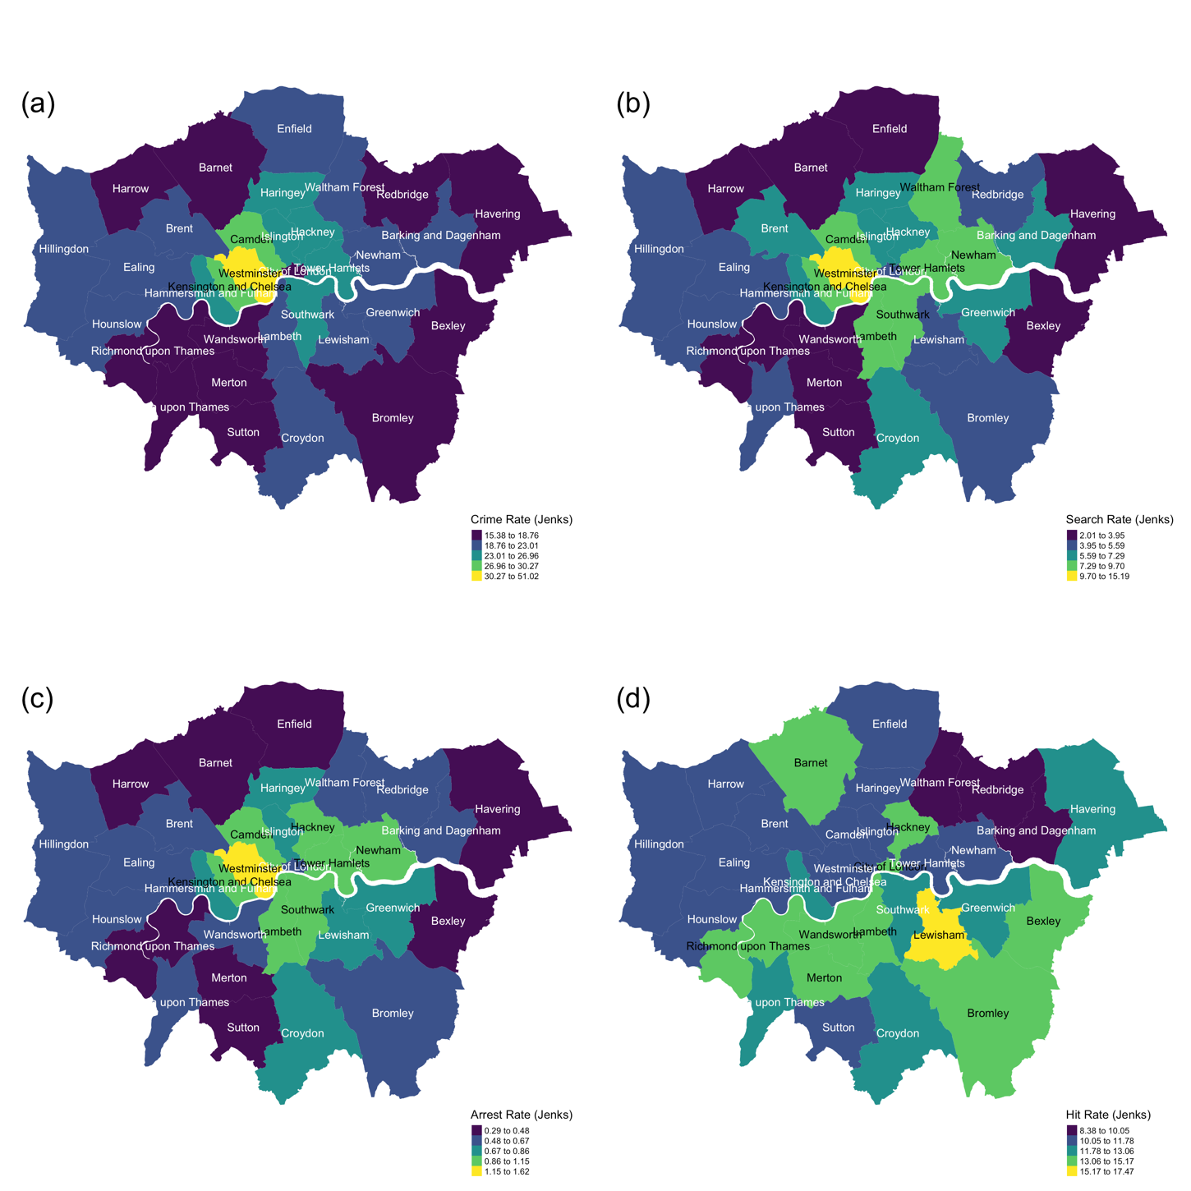

**Figure 5:** Thematic maps of crime rate, search rate, arrest rate, and hit rate across London Boroughs. The natural break (Jenks) was used to classify data into groups. Data obtained from Data.Police.UK, Greater London, Met Police, April 2019 to April 2021.

## **5.2 Racial Disparities**

To understand the outcome of stop and search by race, first, the result of DBSCAN illustrates clusters of ethnic stop and search arrests based on the arrest location and density (see map (a), (b) and (c) on Figure 5). Map (d) is an overlapped map showing an overall distribution. The center of London is a big cluster with a mixture of ethnic arrests and the outskirt of the city has many dispersed small clusters. Most arrests are of black and white people at the center of London. Asian arrests on the other hand, are not as many as the black or white arrests and many of them at the northeast of London. Different distance parameter used to cluster ethnic arrests suggests different point density in between ethnic clusters. Asian clusters are with the largest distance parameter (550m), suggesting within a cluster of at least 50 stop and search arrests, Asian arrests appeared to be less clustered than black arrests or white arrests.

**Figure 6:** DBSCAN results.

DBSCAN results showing the distribution of stop and search arrests by the blacks, the whites and the Asian on map a, b and c respectively. An overlapping map showing the location of all arrests on map d. Data obtained from Data.Police.UK, Greater London, Met Police, April 2019 to April 2021.

The variation in ethnic arrest quantity and location gives a hint on racial disparity but cannot affirm racial discrimination because it does not account for population variation and hit rate. It means, for example, if more searches are carried out at a black community but very few arrests are found, it suggests the police make stop and search decision not based on reasonable suspicion but racial stereotyping. Indeed, Table 5 proves over-policing towards black people. Although most searches are of blacks (37.8%) and whites (38%), only 14% of London population is blacks (based on 2014 census) whereas 63% is whites. This results in a huge difference between black and white search rate. That is saying, only 4 people were stopped and searched for a hundred of white residents whereas over 18 people were searched for a hundred of black residents. Furthermore, 2.2% of searches has no record of the officer identified race but with a very high hit rate.

**Table 5:** Stop and search statistics by race.

|  |  |  |  |  |  |  |
| --- | --- | --- | --- | --- | --- | --- |
| **Race** | **POP (%)** | **Search (%)** | **Arrest (%)** | **Search Rate (%)** | **Arrest Rate (%)** | **Hit Rate (%)** |
| **NA** |  | 2.2 | 2.6 |  |  | 13.9 |
| **White** | 62.9 | 38.0 | 40.1 | 4.1 | 0.5 | 12.6 |
| **Black** | 14.0 | 37.8 | 39.5 | 18.5 | 2.3 | 12.4 |
| **Other** | 3.6 | 4.6 | 4.1 | 8.7 | 0.9 | 10.7 |
| **Asian** | 19.5 | 17.5 | 13.8 | 6.2 | 0.6 | 9.4 |

The global hit rate of Asians is 2% lower than that of the other two ethnic groups. Figure 7 demonstrates the hit rate of white searches versus minority searches and the dotted diagonal line indicates the two groups have the same hit rate.

**Figure 7:** Hit rate comparison between the whites and the minority. Comparison between hit rate of white searches versus minority group searches (Asian, Black and other ethnic groups) by MSOA. Each diamond represents a MSOA observation and the size of a diamond represent the total number of searches in a MSOA. Data obtained from Data.Police.UK, Greater London, Met Police, April 2019 to April 2021.

A diamond on Figure 7 represents a MSOA observation and the larger the diamond, the more search were conducted in that MSOA. If for example, many large diamonds are below the dotted line, it means the minority hit rate in those MSOA is lower than white hit rate and suggests abuse of search power. From Figure 7, the hit rate of whites and blacks is similar because the number of points above the line and below the line is almost the same; whereas the Asian and white hit rate are more random. Overall, from no obvious evidence shows racial discrimination from ethnic hit rate.

However, combining Table 6 and Figure 8, there are a considerable number of zeroes in Asian hit rate, located at east of Havering and north of Bromley. There are two possible meanings of zero hit rate: first, those areas happen to have no searches nor arrests; second, those areas have searches but no arrests. The first scenario is reasonable but the second might indicate racial discrimination if the search rate in those areas is above the London average. In fact, there are 12 MSOA with zero black hit rate and all of their search rate is below London average; 1 MSOA with zero white hit rate and its search rate is below the average. However, there are 105 MSOA with zero Asian hit rate and 7 of them whose search rate is above the average. They are: 2 MSOA from Havering, 1 from Baking and Dagenham, 1 from Bexley, 1 from Bromley, 1 from Croydon, 1 from Enfield.

**Table 6:** MSOA-aggregated hit rate statistics by race.

|  |  |  |  |  |  |  |  |
| --- | --- | --- | --- | --- | --- | --- | --- |
| **Hit Rate** | **Min.** | **1st Qu.** | **Median** | **Mean** | **3rd Qu.** | **Max.** | **# of NAs** |
| Black | 1.69 | 10.09 | 12.65 | 13.58 | 16.13 | 55.56 | 12 |
| White | 2.63 | 10.14 | 13.23 | 13.65 | 16.56 | 42.11 | 1 |
| Asian | 1.47 | 7.28 | 9.79 | 11.51 | 13.64 | 80.00 | 105 |

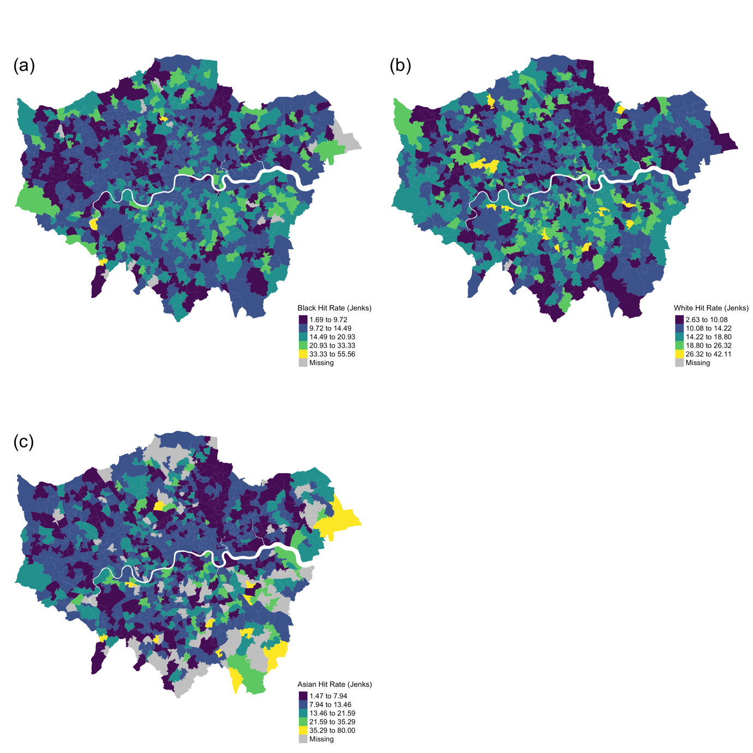

**Figure 8:** Thematic maps of hit rate by race.

Thematic maps of hit rate by race. The natural break (Jenks) was used to classify data into groups. Data obtained from Data.Police.UK, Greater London, Met Police, April 2019 to April 2021.

## **5.3 Stop and Search Hotspots**

The global Moran’s I and Geary’s C statistics are summarized in Table 7. All search and arrest variables have a moderate and positive spatial clustering because Moran’s I statistics higher than 0.3 and Geary’s C statistics lower than 1.

**Table 7:** Global Moran's I statistics for variables used in regression analysis.

|  |  |  |  |  |
| --- | --- | --- | --- | --- |
| **Variable (rate)** | **Global Moran’s I** | | **Geary's C** | |
| **Moran I statistic** | **p-value** | **Geary C statistic** | **p-value** |
| Black search rate | 0.37 | 0 | 0.61 | 0 |
| white search rate | 0.34 | 0 | 0.70 | 0 |
| Asian search rate | 0.41 | 0 | 0.60 | 0 |
| Black arrest rate | 0.34 | 0 | 0.64 | 0 |
| White arrest rate | 0.33 | 0 | 0.70 | 0 |
| Asian arrest rate | 0.32 | 0 | 0.70 | 0 |

The LISA maps on Figure 9 compares ethnic search hotspots (Map a, c, e) to ethnic population hotspots (Map b, d, f) as well as to crime hotspots (Map g). Regardless of race, high stop and search rate were clustered at the centre of London which is also where most crimes located at. The ethnic search hotspots were not corresponding to the ethnic population hotspots, contradicting with Miller *et al.*’s findings (2020). Instead, the black and the white search hotspots were, to some degree, consistent to cold spots of ethnic population instead of hotspots. Similarly, boroughs at northeast of London such as Newham, Barking and Dagenham, and Redbridge were identified as clusters of Asian community but more white searches were carried out there.

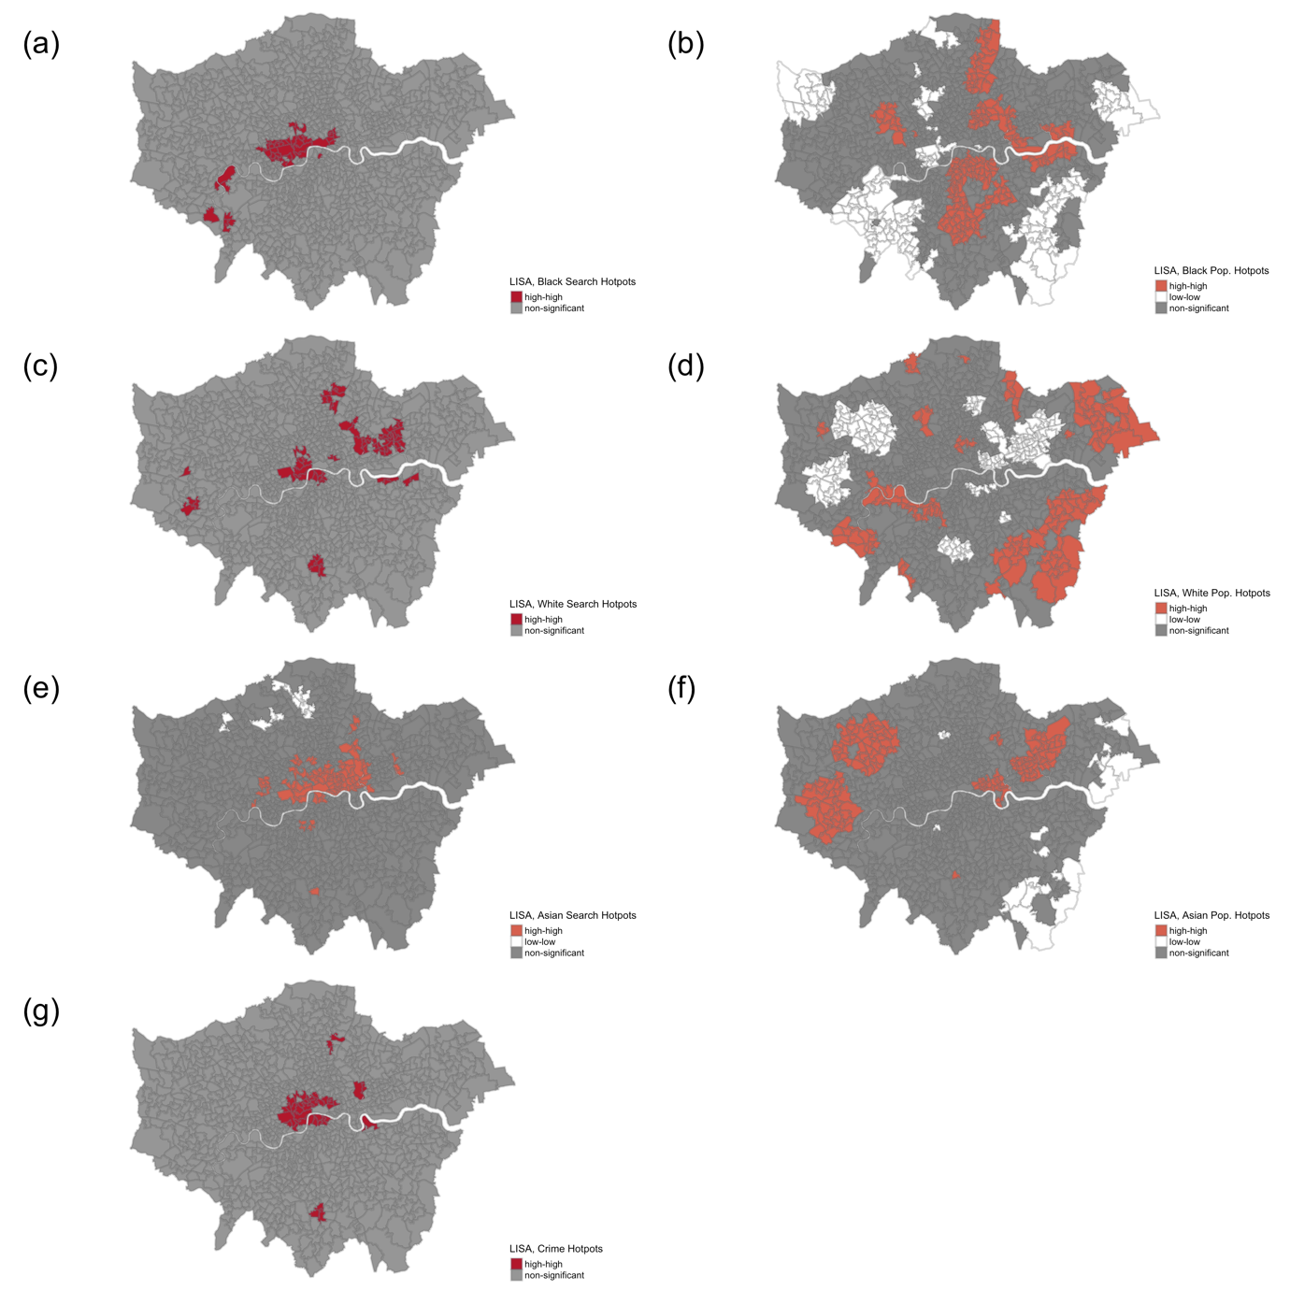

**Figure 9:** Local indicators of spatial association (LISA) maps generated from local Moran’s I and spatial lagged values. It identifies ethnic search hotspots (areas labelled ‘High-High’) and cold-spots (areas labelled ‘Low-Low’) at (a), (c) and (e) and in comparing to ethnic population hotspots (b), (d) and (f) as well as crime hotspots at (g). Data obtained from Data.Police.UK, Greater London, Met Police, April 2019 to April 2021.

## **5.4 Regression Models**

The following tables show the outcome of regression analysis of arrest rate in relation to search rate and inner or outer London for a global relationship (Table 8), whites (Table 9), blacks (Table 10), and Asians (Table 11). The search and arrest rate of blacks and Asians can be explained by a standard OLS regression due to spatial random while the OLS residuals from the global model and white model are spatially correlated (Moran’s I > 0.2), so local coefficients are computed and mapped via GWR (see Figure 10).

**Table 8:** Regression results of global arrest rate in relation to search rate and inner outer London.



**Table 9**: Regression results of white arrest rate in relation to white search rate and inner outer London.



**Table 10:** Regression results of black arrest rate in relation to black search rate and inner outer London.



**Table 11:** Regression results of Asian arrest rate in relation to Asian search rate and inner outer London.



***Relationship between arrest rate and socioeconomic factors***

The following table shows the outcome of regression analysis of arrest rate in relation to crime rate and other socioeconomic factors. After variable selection, the variables used in the OLS were logged crime rate, logged household median income, teenager obesity percent, logged lone parent with dependent child percent, bad health percent, and availability of car or van percent. Since the OLS residuals are not spatially correlated (global Moran’s I < 0.2), the resulting coefficients account for a global variation.

**Table 12:** Regression results of global arrest rate in relation to multiple socioeconomic factors.



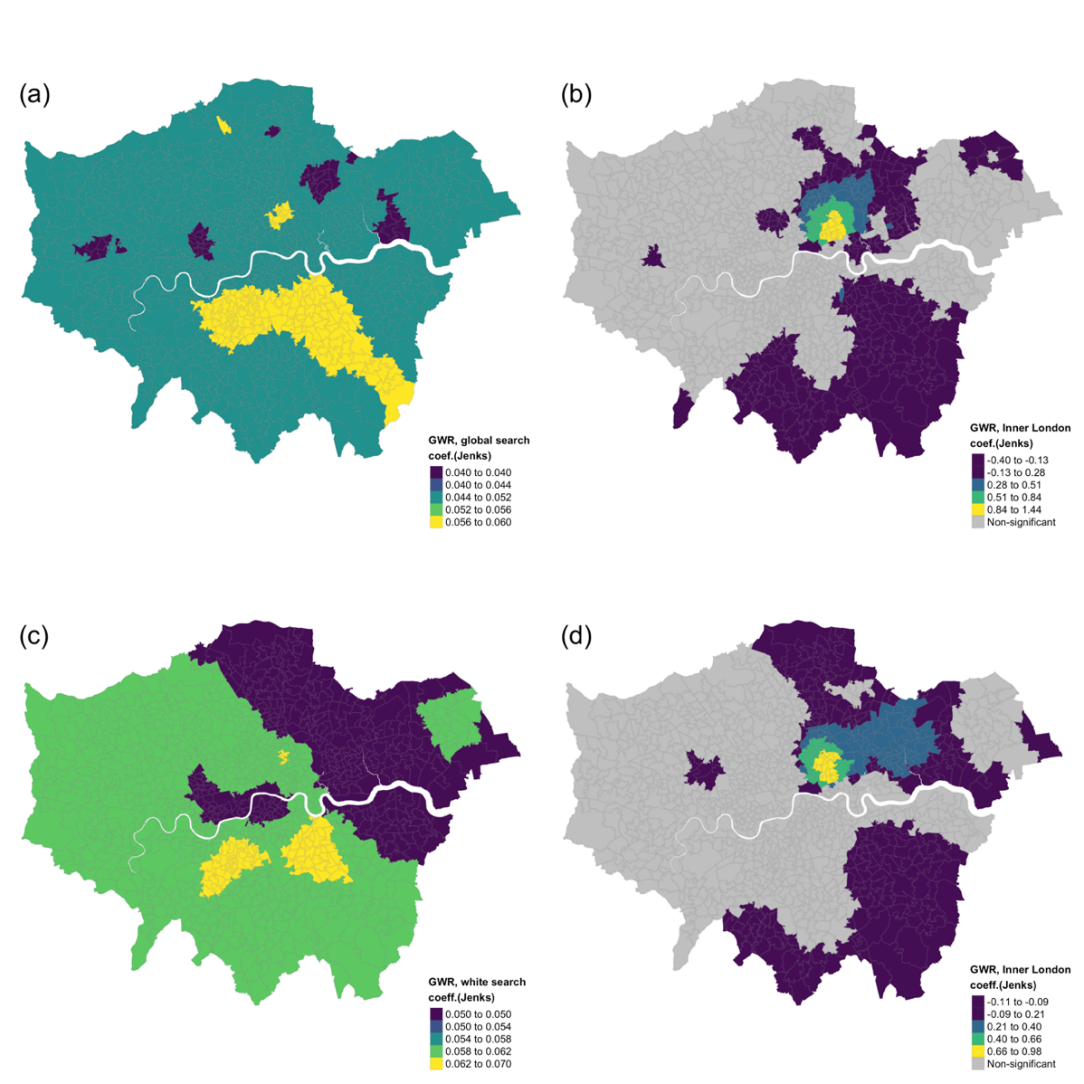

**Figure 10:** Maps of GWR results. The local coefficients of GWR that of the total arrest rate in relation to total search rate (a), the total arrest rate in relation to Inner London (b), the white arrest rate in relation to white search rate (c), and the white arrest rate in relation to Inner London (d). The natural break (Jenks) was used to classify data into groups. Data obtained from Data.Police.UK, Greater London, Met Police, April 2019 to April 2021.

**Chapter 6**

# **Discussion**

This chapter explains the results of the analysis carried out in Chapter 5 to answer whether there is evidence of potential racial discrimination in police use of stop and search powers in London during the past two years, and subsequently whether the stop and search arrest rate can be predicted by the search rate and other socioeconomic factors. For the purpose of “intelligence-led” stop and search, this paper demonstrates a combined use of hotspot and geographically weighted regression analysis to discover areas that are more likely to lead successful stop and search. In comparing stop and search outcome by legislation, by race, and by boroughs, many issues are found and the response to the issues might improve the stop and search performance and help police rebuild trust in minority communities.

***The purpose of stop and search***

Between April 2019 and April 2021, only 12% of stop and searches lead to an arrest. Over 60% of searches was to find drugs but only 10% of them leading to an arrest. By contrast, only 0.5% of searches was to find firearms but 22% of them leads to an arrest. Searching for both drugs and firearms require reasonable suspicion but clearly the outcome test reveals distinct performances between the two, so I doubt searches are based on the equal weight of suspicion regardless of search types.

The use of non-suspicion searches by section 60 increased by 2% between April 2019 and March 2020[1] and decreased by 53% in the following year until April 2021. The sudden drop is possibly because the Home Office’s 1-year plan that encouraging stop and search to target at violent crime did not achieved, so very few section 60 (n=4593) were conducted in the following year of 2020. In fact, the implementation of the plan fails to lead more successful arrests of carrying with offensive weapons. During the past two years, drugs remained the most searched object in all London boroughs even though drug-related incidents only took 5% of total reported crimes. Drug searches in some of the boroughs such as Waltham Forest and Barking and Dagenham resulted in a relatively low hit rate, suggesting the police could reconsider the search priority in those boroughs. On the other hand, drug searches at Lewisham, Wandsworth, Barnet and Bexley were very effective.

Therefore, the comparison between hit rate and search rate across broughs could help select ‘targeted’ boroughs for drug searches (i.e., the one often yields high hit rate based on the past data) and decrease drug searches in other boroughs so that the police have the time to tackle violent crimes.

***Racial discrimination***

From April 2019 to April 2021, 38% of searches was of blacks or whites, leaving only 24% of other ethnic groups. If taking population into account, the difference between white and black search rate is almost five-fold. The police’s tendency to search black people might because of a higher black arrest rate; indeed, the black arrest rate was five times larger the other ethnic arrest rate during the past two years. However, this study did not find ethnic crime data so failed to further investigate whether the ethnic stop and search arrest rate is corresponding to ethnic crime rate.

The racial disparities also occurred in search of Asians. The proportion of Asian searches is 17.5%, almost half of whites or blacks; however, considering the insignificant proportion of Asian population in Greater London (20%), the Asian search rate was higher than the white’s (6.2% and 4.1% respectively) but the Asian hit rate was lower than the white’s (9.4% and 12.6%). Moreover, search of Asians at Barking and Dagenham 013, Bexley 008 and 020, Bromley 04, Croydon 036, and Enfield 008 were above the London average Asian search rate but none of the searches led to an arrest, and those areas only have 0 to 20% of total Asian population of London, so theoretically not many Asians would be available on the street. All this suggests the police might stop and search Asian people based on racial stereotyping not reasonable suspicion, corresponding to findings from previous studies (Bowling and Phillips, 2007; Yesufu, 2013; Miller *et al.*, 2020).

However, contradicting with Miller *et al.*'s argument on "geographic profiling" that the police focused on searching minority neighborhoods rather than crime hotspots, the LISA maps (see Figure 9) illustrate the ethnic search hotspots were not corresponding to their population hotspots based on the 2014 census ethnic resident population data. Moreover, also contradicting with Chainey and Macdonald’s finding (2012) that search hotspot was inconsistent with crime hotspots, the results of the analysis show search hotspots indeed correspond to crime hotspots at the center of London. Different outcome between studies might because the population density has changed significantly since the last census collection and thus using outdated population estimation to associate current stop and search could lead to an inaccurate interpretation. Due to a lack of the street population data, the conclusion of racial discrimination could not be affirmed; however, the above evidence is sufficient to show some broughs were doing better than the others and the reason might because of a comprehensive training program.

To policymakers, I suggest a critical review on the use of stop and search by race should be required to every police force and let officers reflect and share their experience of successful searches. In addition, boroughs or MSOAs that have been labelled as “racial biased” should be regularly monitored, and as Delsol and Shiner (2006) suggested, the supervision from third-party might be more appropriate to avoid bureaucracy.

***Effectiveness of stop and search***

The results of regression analysis can evaluate the effectiveness of stop and search at MSOA level. Globally, one-unit increase in search rate leads to 0.1 increase in arrest rate (see Table 8). When accounting for local variation, all boroughs have a positive search-arrest relationship, but the impact is positively stronger at southeast of London at Southward, Lewisham, Bromley, Lambeth, Wandsworth and Merton with 0.02 percent difference to other boroughs (see Figure 10.a). The ethnic search versus arrest relationship (see Table 9, 10, 11) all follow the global trend of 0.1 percent growth except for the white arrest rate which is subject to local variation. Increasing one percent of white search rate in areas near Lewisam and south of Lambeth results 0.03 percent higher in white arrest rate than other boroughs, but the difference among boroughs is less than 0.1 percent. Living in Inner London will increase the arrest rate by a range of -0.4 to 1.4 percent compared to living in Outer London and arresting white people is more sensitive to the Inner or Outer London boundaries. Overall, the stop and search arrest rate could be explained by a linear combination of search rate and Inner London boundary. The adjusted R-squared values indicate the linear model well fitted to the data; however, the change to the arrest rate is insignificant and there is not much variation in local variation.

Combining with socioeconomic factors, Table 12 shows increasing in crime rate, teenager obesity percent, and ownership of a car percent will increase arrest rate whereas increasing in household income, lone parent with children percent, and bar health percent will decrease arrest rate. Crime and ownership of car have a greater relative effect due to a larger t-value whereas crime and bad health lead to the most change in arrest rate. Ten percent increase in crime rate associates with a 0.1 unit increase in arrest rate whereas one-unit increase in bad health rate associates with a 0.1 unit decrease in arrest rate. Increasing one-unit in other factors lead to less than 0.1 change in arrest rate. Surprisingly, contradicting to the literature suggests, the deprivation index fails to prove statistically important to arrest rates.

In summary, a higher rate of stop and search or crime will lead to a higher arrest rate but the overall effect on arrest rate is very minor (lead to < 0.1 percent increase). The number of successful stop and search might not be determined by the quantity of searches but the quality. The deprivation index fails to associate with arrest rate and unexpectedly, bad health leads to a similar degree of change (0.1 percent) that crime does, but crime results in more arrests while bad health results in less arrests.

***Limitation and future studies***

The disproportionality analysis and the regression models are qualitative measures based on police data. A lack of street population and ethnic crime rate could result in misleading results. Moreover, there is a lack of threshold that quantifies the quality of stop and search; therefore, the results of the analysis might not be effective to decision-making. The results of ST-DBSCAN (see Table 13) provides an example of clustering stop and search by space and time; it could calculate how much time the police have searched in an area and the dominant race or object they have searched for. However, the problem of this algorithm is to set a meaning and reasonable distance and time threshold which corresponds to my previous point of quantifying the quality of stop and search. Therefore, future work could develop a robust way to determine ST-DBSCAN parameters and incorporate spatial-temporal analysis into crime mapping. Furthermore, to assess and quantify the quality of stop and search, previous suggested socioeconomic factors such as deprivation fails to predict arrest rate whereas bad health percent and car ownership are more related to arrests. Future regression analysis could incorporate other factors such as police’s training data if available.

**Table 13:** ST-DBSCAN cluster results. ST-DBSCAN parameters: minimum distance is 1km; minimum time is 1440 mins (= 1 day); minimum points are 10. Data size: a sample of 5000 London stop and search arrest data from April 2019 to April 2021. The table shows the total number of searches in each cluster, the total amount of time that the police have spent searching in the cluster, and the dominant (occurred the most times) ethnic group being stopped and searched.

|  |  |  |  |
| --- | --- | --- | --- |
| **Cluster** | **Total Searches (n)** | **Total Time Spent (min)** | **Ethnicity** |
| 2 | 2736 | 584284 | Black |
| 6 | 134 | 30781 | Black |
| 25 | 127 | 31733 | Black |
| 3 | 93 | 21725 | Asian |
| 11 | 93 | 20019 | Black |
| 26 | 58 | 13097 | Black |
| 8 | 52 | 9100 | White |
| 29 | 47 | 7329 | White |
| 20 | 46 | 9307 | White |
| 14 | 45 | 12317 | White |
| 22 | 39 | 7744 | White |
| 1 | 30 | 8105 | Black |
| 10 | 27 | 7908 | White |
| 12 | 26 | 8556 | Black |
| 5 | 24 | 7713 | White |
| 33 | 23 | 5391 | Black |
| 37 | 20 | 5714 | White |
| 17 | 19 | 3968 | White |
| 24 | 18 | 5223 | White |
| 36 | 17 | 3122 | Black |
| 41 | 17 | 2477 | Black |
| 19 | 16 | 4441 | Black |
| 28 | 16 | 4094 | Black |
| 30 | 16 | 2320 | Black |
| 21 | 16 | 3369 | Black |
| 18 | 14 | 1789 | Black |
| 7 | 13 | 2694 | Asian |
| 13 | 13 | 2646 | White |
| 39 | 12 | 1260 | Black |
| 23 | 11 | 1938 | White |
| 31 | 11 | 2158 | Black |
| 9 | 11 | 1955 | White |
| 27 | 10 | 2297 | Black |
| 32 | 10 | 3232 | Black |
| 35 | 10 | 3112 | White |
| 34 | 9 | 957 | Black |
| 4 | 7 | 1659 | White |
| 15 | 6 | 1055 | White |
| 40 | 6 | 4134 | Black |
| 38 | 5 | 1338 | Black |
| 16 | 4 | 480 | White |

**Chapter 7**

# **Conclusion**

This paper uses multiple spatial analysis to understand the use of stop and search in Greater London during the past two years. Overall, the purpose of stop and search is unclear; if is knife-crime oriented, the Home Office should provide a clear definition of ‘knife-crime’, indicate legislations that are responsible for it, and grant access to ethnic crime data so that the effectiveness of stop and search can be monitored by the public. The results of the analysis reveal the following issues: (1) there is a lack of regulation and uniform standards between forces; (2) officers use racial stereotyping to label suspects based on their race; (3) the reasonable suspicion is not based on the equal weight but changes with search types; (4) and the Met force has over targeted at drug crime but failed to prioritize crime types within boroughs; (5) a higher stop and search rate or crime rate will lead to a higher arrest rate, but the overall effect is very minor (lead to < 0.1 percent increase). The number of successful stop and search might not be determined by the quantity of searches but the quality. To assess and quantify the quality of stop and search, suggested socioeconomic factors such as deprivation fails to predict arrest rate whereas bad health percent and car ownership are more related to arrests. Building upon the suggestion from Eades and Centre for Crime and Justice Studies (Great Britain, 2007) and Commission on Race and Ethnic Disparities (2021), the following suggestions might help improve the effectiveness and fairness of stop and search: (1) information sharing between forces; (2) reducing drug search at non-targeted areas; (3) using hit rate to evaluate policing effectiveness and racial bias; (4) add a field of ‘found weapon’ to the current stop and search dataset to gather solutions to tackle violent crimes from the public. (5) targeting searches at crime or population hotspots is not a quick solution to improve stop and search performance; a long-term strategy is in need.

# **Bibliography**

Anselin, L. (1995). ‘Local Indicators of Spatial Association—LISA’. *Geographical Analysis*, 27 (2), pp. 93–115. doi: 10.1111/j.1538-4632.1995.tb00338.x.

Birant, D. and Kut, A. (2007). ‘ST-DBSCAN: An algorithm for clustering spatial–temporal data’. *Data & Knowledge Engineering*. (Intelligent Data Mining), 60 (1), pp. 208–221. doi: 10.1016/j.datak.2006.01.013.

Bowling, B. and Phillips, C. (2007). ‘Disproportionate and Discriminatory: Reviewing the Evidence on Police Stop and Search’. *The Modern Law Review*, 70 (6), pp. 936–961. doi: https://doi.org/10.1111/j.1468-2230.2007.00671.x.

Bowling, B. and Weber, L. (2011). ‘Stop and search in global context: an overview’. *Policing and Society*. Routledge, 21 (4), pp. 480–488. doi: 10.1080/10439463.2011.618735.

Bradford, B. and Tiratelli, M. (2019). ‘Does stop and search reduce crime?’, (4), p. 14.

Brookman, F. and Maguire, M. (2005). ‘Reducing homicide: A review of the possibilities’. *Crime, Law and Social Change*, 42 (4–5), pp. 325–403. doi: 10.1007/s10611-005-1931-4.

Brown, J. (2019). ‘Stop-and-search powers: Extension of “no-suspicion” searches’. Available at: https://commonslibrary.parliament.uk/stop-and-search-powers-extension-of-no-suspicion-searches/ (Accessed: 23 March 2021).

Brusilovskiy, E., Klein, L. A., Townley, G., Snethen, G., McCormick, B., Hiremath, S. V. and Salzer, M. S. (2020). ‘Examining the relationship between community mobility and participation using GPS and self-report data’. *Social Science & Medicine*, 265, p. 113539. doi: 10.1016/j.socscimed.2020.113539.

Bui, L. V., Mor, Z., Chemtob, D., Ha, S. T. and Levine, H. (2018). ‘Use of Geographically Weighted Poisson Regression to examine the effect of distance on Tuberculosis incidence: A case study in Nam Dinh, Vietnam’. *PLOS ONE*. Public Library of Science, 13 (11), p. e0207068. doi: 10.1371/journal.pone.0207068.

Chainey, S. and Macdonald, I. (2012). ‘Stop and search, the use of intelligence and geographic targeting’, p. 97.

Clark, N. (2021). *nmclark2/SCION*. Available at: https://github.com/nmclark2/SCION (Accessed: 8 June 2021).

Commission (EHRC), E. and H. R. (2010). *Stop and think : a critical review of the use of stop and search powers in England and Wales*. *spec.inst*. report. EHRC. Available at: https://tandis.odihr.pl/handle/20.500.12389/21098 (Accessed: 24 March 2021).

Commission on Race and Ethnic Disparities. (2021). *Crime and policing*. *GOV.UK*. Available at: https://www.gov.uk/government/publications/the-report-of-the-commission-on-race-and-ethnic-disparities/crime-and-policing (Accessed: 3 August 2021).

Constabulary, © Her Majesty’s Inspectorate of and Fire. (2013). *Stop and Search Powers: Are the police using them effectively and fairly?* *HMICFRS*. Available at: https://www.justiceinspectorates.gov.uk/hmicfrs/publications/stop-and-search-powers-20130709/ (Accessed: 9 August 2021).

Constabulary, © Her Majesty’s Inspectorate of and Fire. (2021). *Disproportionate use of police powers - A spotlight on stop and search and the use of force*. *HMICFRS*. Available at: https://www.justiceinspectorates.gov.uk/hmicfrs/publications/disproportionate-use-of-police-powers-a-spotlight-on-stop-and-search-and-the-use-of-force/ (Accessed: 9 August 2021).

Delsol, R. and Shiner, M. (2006). ‘Regulating stop and search: a challenge for police and community relations in England and Wales’. *Critical Criminology*, 14 (3), pp. 241–263. doi: 10.1007/s10612-006-9013-1.

Eades, C. and Centre for Crime and Justice Studies (Great Britain). (2007). *‘Knife crime’: a review of evidence and policy*. London: Centre for Crime and Justice Studies. Available at: http://www.crimeandjustice.org.uk/opus439/ccjs_knife_report.pdf (Accessed: 11 June 2021).

Eck, J., Chainey, S., Cameron, J. and Wilson, R. (2005). *Mapping crime: Understanding Hotspots*. *National Institute of Justice: Washington DC.* Report. Washington DC: National Institute of Justice, pp. 1–71. Available at: https://discovery.ucl.ac.uk/id/eprint/11291/ (Accessed: 16 August 2021).

EVANS, D. (2001). ‘Spatial Analyses of Crime’. *Geography*. Geographical Association, 86 (3), pp. 211–223.

Gordon McDonald. (2020). *Example Clustering of Google Location History*. Available at: https://gdmcdonald.github.io/stdbscanr/google_location_example.html (Accessed: 8 June 2021).

Hahsler, M. (2021). *mhahsler/dbscan*. Available at: https://github.com/mhahsler/dbscan (Accessed: 8 June 2021).

Hahsler, M., Piekenbrock, M. and Doran, D. (2019). ‘dbscan: Fast Density-Based Clustering with R’. *Journal of Statistical Software*, 91 (1), pp. 1–30. doi: 10.18637/jss.v091.i01.

Home Office. (2019). *Greater powers for police to use stop and search to tackle violent crime*. *GOV.UK*. Available at: https://www.gov.uk/government/news/greater-powers-for-police-to-use-stop-and-search-to-tackle-violent-crime (Accessed: 8 June 2021).

Jaraha, E. (2021). *sjaraha/clustering-spatiotemporal-data*. Available at: https://github.com/sjaraha/clustering-spatiotemporal-data (Accessed: 8 June 2021).

Kerouanton. (2021). *Kersauson/ST-DBSCAN*. Available at: https://github.com/Kersauson/ST-DBSCAN (Accessed: 8 June 2021).

Martin Beckford. (2020). ‘Stop-and-search use in London rose 40% in lockdown, figures show’. *the Guardian*, 25 August. Available at: http://www.theguardian.com/uk-news/2020/aug/25/stop-and-search-use-in-london-rose-40-in-lockdown-figures-show (Accessed: 16 August 2021).

Matt Ashby. (2020). *Stop and search in London*, p. 9.

McDonald, G. (2020). *gdmcdonald/stdbscanr*. Available at: https://github.com/gdmcdonald/stdbscanr (Accessed: 8 June 2021).

Medina, R. S. and J. (2021). *Chapter 7 Global and local spatial autocorrelation | Crime Mapping in R*. Available at: https://maczokni.github.io/crime_mapping_textbook/global-and-local-spatial-autocorrelation.html#local-spatial-autocorrelation (Accessed: 17 August 2021).

Mencken, F. C. and Barnett, C. (1999). ‘Murder, Nonnegligent Manslaughter, and Spatial Autocorrelation in Mid-South Counties’. *Journal of Quantitative Criminology*, 15 (4), pp. 407–422. doi: 10.1023/A:1007592124641.

Miller, J., Quinton, P., Alexandrou, B. and Packham, D. (2020). ‘Can police training reduce ethnic/racial disparities in stop and search? Evidence from a multisite UK trial’. *Criminology & Public Policy*, 19 (4), pp. 1259–1287. doi: https://doi.org/10.1111/1745-9133.12524.

NHS. (2021). *Middle Layer Super Output Area*. Available at: https://datadictionary.nhs.uk/nhs_business_definitions/middle_layer_super_output_area.html (Accessed: 16 August 2021).

Pageon, S. V., Nicovich, P. R., Mollazade, M., Tabarin, T. and Gaus, K. (2016). ‘Clus-DoC: a combined cluster detection and colocalization analysis for single-molecule localization microscopy data’. *Molecular Biology of the Cell*, 27 (22), pp. 3627–3636. doi: 10.1091/mbc.E16-07-0478.

Pierson, E., Simoiu, C., Overgoor, J., Corbett-Davies, S., Jenson, D., Shoemaker, A., Ramachandran, V., Barghouty, P., Phillips, C., Shroff, R. and Goel, S. (2020). ‘A large-scale analysis of racial disparities in police stops across the United States’. *Nature Human Behaviour*, 4 (7), pp. 736–745. doi: 10.1038/s41562-020-0858-1.

Quinton, P. (2011). ‘The formation of suspicions: police stop and search practices in England and Wales’. *Policing and Society*. Routledge, 21 (4), pp. 357–368. doi: 10.1080/10439463.2011.610193.

Ratcliffe, J. (2010). ‘Crime Mapping: Spatial and Temporal Challenges’. in Piquero, A. R. and Weisburd, D. (eds) *Handbook of Quantitative Criminology*. New York, NY: Springer New York, pp. 5–24. doi: 10.1007/978-0-387-77650-7_2.

Rogers, A., Castree, N. and Kitchin, R. (2013). ‘Tobler’s first law of geography’. in *A Dictionary of Human Geography*. Oxford University Press. Available at: https://www.oxfordreference.com/view/10.1093/acref/9780199599868.001.0001/acref-9780199599868-e-1896 (Accessed: 17 August 2021).

The National Archives. (no date). *Open Government Licence*. Available at: https://www.nationalarchives.gov.uk/doc/open-government-licence/version/3/ (Accessed: 17 August 2021).

Tiratelli, M., Quinton, P. and Bradford, B. (2018). ‘Does Stop and Search Deter Crime? Evidence From Ten Years of London-wide Data’. *The British Journal of Criminology*, 58 (5), pp. 1212–1231. doi: 10.1093/bjc/azx085.

Wooditch, A. and Weisburd, D. (2016). ‘Using Space–Time Analysis to Evaluate Criminal Justice Programs: An Application to Stop-Question-Frisk Practices’. *Journal of Quantitative Criminology*, 32 (2), pp. 191–213. doi: 10.1007/s10940-015-9259-4.

Wortley, S. and Owusu-Bempah, A. (2011). ‘The usual suspects: police stop and search practices in Canada’. *Policing and Society*. Routledge, 21 (4), pp. 395–407. doi: 10.1080/10439463.2011.610198.

Yesufu, S. (2013). ‘Discriminatory Use of Police Stop-and-Search Powers in London, UK’. *International Journal of Police Science & Management*. SAGE Publications Ltd, 15 (4), pp. 281–293. doi: 10.1350/ijps.2013.15.4.318.

1. Data obtained from StopWatch at https://www.stop-watch.org/your-area/area/metropolitan